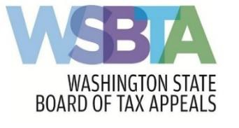
Address 1110 Capitol Way South, Suite 307 (P.O. Box 40915) Olympia, WA 98504-0915
Main (360) 753-5446 | Toll-Free (844) 880-8794 | Fax (360) 586-9020
Email bta@bta.wa.gov | Website bta.wa.gov

RPC 3.1 and CR 11 Certification

The undersigned representative appearing before the Washington State Board of Tax Appeals certifies that, to the best of his or her knowledge, information, and belief, formed after reasonable inquiry under the circumstances that the appeals for the petition numbers identified below are well- grounded in fact; warranted by existing law or a good faith argument for the extension, modification, or reversal of existing law or the establishment of new law; and not interposed for any improper purpose.

Signed this day of , 2019 in County,

State.

Signature of Appearing Representative

Print Name:

Petition numbers:

